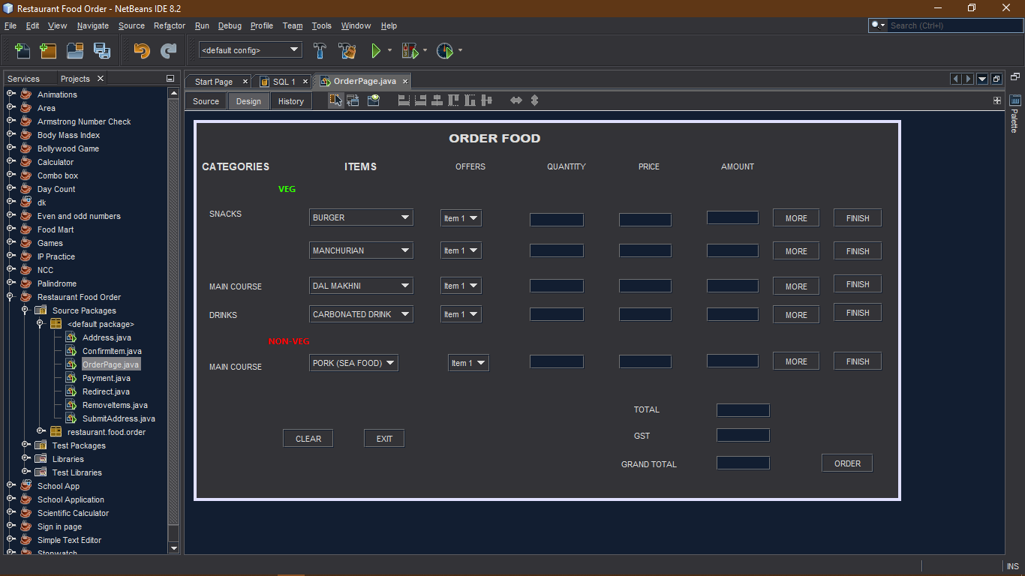**Restaurant Food Order**

**Frame 1 : Order Food**

**public class OrderPage extends javax.swing.JFrame {**

int amount=0;

static String c1;

static String c2;

static String c3;

static String c4;

static String c5;

**private void jComboBox1ActionPerformed(java.awt.event.ActionEvent evt) {**

String x= (String) jComboBox1.getSelectedItem();

if(x.equals("BURGER"))

{

jTextField1.setText(""+50);

}

else if(x.equals("PIZZA"))

{

jTextField1.setText("150");

}

else if(x.equals("SUB"))

{

jTextField1.setText("210");

}

if(x.equals("PASTA"))

{

jTextField1.setText("170");

}

if(x.equals("NOODLES"))

{

jTextField1.setText("100");

}

**}**

**private void formWindowOpened(java.awt.event.WindowEvent evt) {**

jComboBox2.setEnabled(false);

jComboBox3.setEnabled(false);

jComboBox4.setEnabled(false);

jComboBox5.setEnabled(false);

jComboBox7.setEnabled(false);

jComboBox8.setEnabled(false);

jComboBox9.setEnabled(false);

jComboBox10.setEnabled(false);

jTextField2.setEnabled(false);

jTextField3.setEnabled(false);

jTextField4.setEnabled(false);

jTextField5.setEnabled(false);

jTextField7.setEnabled(false);

jTextField8.setEnabled(false);

jTextField9.setEnabled(false);

jTextField10.setEnabled(false);

jTextField12.setEnabled(false);

jTextField13.setEnabled(false);

jTextField14.setEnabled(false);

jTextField15.setEnabled(false);

jTextField16.setEnabled(false);

jTextField17.setEnabled(false);

jTextField18.setEnabled(false);

jButton4.setEnabled(false);

jButton5.setEnabled(false);

jButton6.setEnabled(false);

jButton7.setEnabled(false);

jButton9.setEnabled(false);

jButton10.setEnabled(false);

jButton11.setEnabled(false);

jButton12.setEnabled(false);

jButton13.setEnabled(false);

**}**

**private void jTextField11ActionPerformed(java.awt.event.ActionEvent evt) {**

int y= Integer.parseInt(jTextField11.getText());

int price= Integer.parseInt(jTextField1.getText());

jTextField6.setText(""+y*price);

int amount1= Integer.parseInt(jTextField6.getText());

amount=amount+amount1;

**}**

**private void jButton3ActionPerformed(java.awt.event.ActionEvent evt) {**

c1 = jComboBox1.getSelectedItem() + "\t" + jTextField11.getText() + "\n";

jTextField11.setText("");

jTextField1.setText("");

jTextField6.setText("");

**}**

**private void jComboBox2ActionPerformed(java.awt.event.ActionEvent evt) {**

String x= (String) jComboBox2.getSelectedItem();

if(x.equals("MANCHURIAN"))

{

jTextField2.setText(""+180);

}

else if(x.equals("BULLETS"))

{

jTextField2.setText("50");

}

else if(x.equals("FRENCH FRIES"))

{

jTextField2.setText("180");

}

if(x.equals("PAV BHAJI"))

{

jTextField2.setText("70");

}

if(x.equals("CHEESE CHILLI"))

{

jTextField2.setText("210");

}

**}**

**private void jButton8ActionPerformed(java.awt.event.ActionEvent evt) {**

c1 = "\n" + jComboBox1.getSelectedItem() + "\t" + jTextField11.getText() + "\n";

jComboBox1.setEnabled(false);

jComboBox2.setEnabled(true);

jComboBox6.setEnabled(false);

jComboBox7.setEnabled(true);

jTextField11.setEnabled(false);

jTextField1.setEnabled(false);

jTextField6.setEnabled(false);

jTextField12.setEnabled(true);

jTextField2.setEnabled(true);

jTextField7.setEnabled(true);

jButton3.setEnabled(false);

jButton8.setEnabled(false);

jButton4.setEnabled(true);

jButton9.setEnabled(true);

jTextField11.setText("");

jTextField1.setText("");

jTextField6.setText("");

**}**

**private void jButton9ActionPerformed(java.awt.event.ActionEvent evt) {**

c2 = jComboBox2.getSelectedItem() + "\t" + jTextField12.getText() + "\n";

jComboBox2.setEnabled(false);

jComboBox3.setEnabled(true);

jComboBox7.setEnabled(false);

jComboBox8.setEnabled(true);

jTextField12.setEnabled(false);

jTextField2.setEnabled(false);

jTextField7.setEnabled(false);

jTextField13.setEnabled(true);

jTextField3.setEnabled(true);

jTextField8.setEnabled(true);

jButton4.setEnabled(false);

jButton9.setEnabled(false);

jButton5.setEnabled(true);

jButton10.setEnabled(true);

jTextField12.setText("");

jTextField2.setText("");

jTextField7.setText("");

**}**

**private void jTextField12ActionPerformed(java.awt.event.ActionEvent evt) {**

int y= Integer.parseInt(jTextField12.getText());

int price= Integer.parseInt(jTextField2.getText());

jTextField7.setText(""+y*price);

int amount2= Integer.parseInt(jTextField7.getText());

amount=amount+amount2;

**}**

**private void jTextField13ActionPerformed(java.awt.event.ActionEvent evt) {**

int y= Integer.parseInt(jTextField13.getText());

int price= Integer.parseInt(jTextField3.getText());

jTextField8.setText(""+y*price);

int amount3= Integer.parseInt(jTextField8.getText());

amount=amount+amount3;

**}**

**private void jButton10ActionPerformed(java.awt.event.ActionEvent evt) {**

c3= jComboBox3.getSelectedItem() + "\t" + jTextField13.getText() + "\n";

jComboBox3.setEnabled(false);

jComboBox4.setEnabled(true);

jComboBox8.setEnabled(false);

jComboBox9.setEnabled(true);

jTextField13.setEnabled(false);

jTextField3.setEnabled(false);

jTextField8.setEnabled(false);

jTextField14.setEnabled(true);

jTextField4.setEnabled(true);

jTextField9.setEnabled(true);

jButton5.setEnabled(false);

jButton10.setEnabled(false);

jButton6.setEnabled(true);

jButton11.setEnabled(true);

jTextField13.setText("");

jTextField3.setText("");

jTextField8.setText("");

**}**

**private void jButton11ActionPerformed(java.awt.event.ActionEvent evt) {**

c4 = jComboBox4.getSelectedItem() + "\t" + jTextField14.getText() + "\n";

jComboBox4.setEnabled(false);

jComboBox5.setEnabled(true);

jComboBox9.setEnabled(false);

jComboBox10.setEnabled(true);

jTextField14.setEnabled(false);

jTextField4.setEnabled(false);

jTextField9.setEnabled(false);

jTextField15.setEnabled(true);

jTextField5.setEnabled(true);

jTextField10.setEnabled(true);

jButton6.setEnabled(false);

jButton11.setEnabled(false);

jButton7.setEnabled(true);

jButton12.setEnabled(true);

jTextField14.setText("");

jTextField4.setText("");

jTextField9.setText("");

**}**

**private void jButton4ActionPerformed(java.awt.event.ActionEvent evt) {**

c2 = jComboBox2.getSelectedItem() + "\t" + "\t" + jTextField12.getText() + "\n";

jTextField12.setText("");

jTextField2.setText("");

jTextField7.setText("");

**}**

**private void jButton5ActionPerformed(java.awt.event.ActionEvent evt) {**

c3 = jComboBox3.getSelectedItem() + "\t" + "\t" + jTextField13.getText() + "\n";

jTextField13.setText("");

jTextField3.setText("");

jTextField8.setText("");

**}**

**private void jButton6ActionPerformed(java.awt.event.ActionEvent evt) {**

c4 = jComboBox4.getSelectedItem() + "\t" + "\t" + jTextField14.getText() + "\n";

jTextField14.setText("");

jTextField4.setText("");

jTextField9.setText("");

**}**

**private void jButton7ActionPerformed(java.awt.event.ActionEvent evt) {**

c5 = jComboBox5.getSelectedItem() + "\t" + "\t" + jTextField15.getText() + "\n";

jTextField15.setText("");

jTextField5.setText("");

jTextField10.setText("");

**}**

**private void jButton12ActionPerformed(java.awt.event.ActionEvent evt) {**

c5 = jComboBox5.getSelectedItem() + "\t" + "\t" + jTextField15.getText() + "\n";

jButton7.setEnabled(false);

jButton12.setEnabled(false);

jTextField16.setEnabled(true);

jTextField17.setEnabled(true);

jTextField18.setEnabled(true);

jTextField15.setText("");

jTextField5.setText("");

jTextField10.setText("");

jTextField16.setText(""+amount);

jTextField17.setText(""+(0.12*(Integer.parseInt(jTextField16.getText()))));

double total= Double.parseDouble(jTextField16.getText());

double gst= Double.parseDouble(jTextField17.getText());

double grand=gst+total;

jTextField18.setText(Double.toString(grand));

jButton13.setEnabled(true);

**}**

**private void jTextField15ActionPerformed(java.awt.event.ActionEvent evt) {**

int y= Integer.parseInt(jTextField15.getText());

int price= Integer.parseInt(jTextField5.getText());

jTextField10.setText(""+y*price);

int amount5= Integer.parseInt(jTextField10.getText());

amount=amount+amount5;

**}**

**private void jTextField14ActionPerformed(java.awt.event.ActionEvent evt) {**

int y= Integer.parseInt(jTextField14.getText());

int price= Integer.parseInt(jTextField4.getText());

jTextField9.setText(""+y*price);

int amount4= Integer.parseInt(jTextField9.getText());

amount=amount+amount4;

**}**

**private void jComboBox3ActionPerformed(java.awt.event.ActionEvent evt) {**

String x= (String) jComboBox3.getSelectedItem();

if(x.equals("DAL MAKHNI"))

{

jTextField3.setText("260");

}

else if(x.equals("CHEESE TOMATO"))

{

jTextField3.setText("365");

}

else if(x.equals("SALAD"))

{

jTextField3.setText("180");

}

if(x.equals("BUTTER ROTI"))

{

jTextField3.setText("20");

}

if(x.equals("NAAN"))

{

jTextField3.setText("35");

}

**}**

**private void jComboBox4ActionPerformed(java.awt.event.ActionEvent evt) {**

String x= (String) jComboBox4.getSelectedItem();

if(x.equals("CARBONATED DRINK"))

{

jTextField4.setText("35");

}

else if(x.equals("VIRGIN MOJITO"))

{

jTextField4.setText("150");

}

else if(x.equals("BLUE LAGOON"))

{

jTextField4.setText("150");

}

if(x.equals("COFFEE"))

{

jTextField4.setText("30");

}

if(x.equals("TEA"))

{

jTextField4.setText("25");

}

**}**

**private void jComboBox5ActionPerformed(java.awt.event.ActionEvent evt) {**

String x= (String) jComboBox5.getSelectedItem();

if(x.equals("PORK (SEA FOOD)"))

{

jTextField5.setText("700");

}

else if(x.equals("BUTTER CHICKEN"))

{

jTextField5.setText("595");

}

else if(x.equals("DRY FISH"))

{

jTextField5.setText("250");

}

if(x.equals("SUB"))

{

jTextField5.setText("270");

}

if(x.equals("BURGER"))

{

jTextField5.setText("125");

}

**}**

**private void jButton2ActionPerformed(java.awt.event.ActionEvent evt) {**

System.exit(0);

**}**

**private void jButton1ActionPerformed(java.awt.event.ActionEvent evt) {**

jComboBox2.setEnabled(false);

jComboBox3.setEnabled(false);

jComboBox4.setEnabled(false);

jComboBox5.setEnabled(false);

jComboBox7.setEnabled(false);

jComboBox8.setEnabled(false);

jComboBox9.setEnabled(false);

jComboBox10.setEnabled(false);

jTextField2.setEnabled(false);

jTextField3.setEnabled(false);

jTextField4.setEnabled(false);

jTextField5.setEnabled(false);

jTextField7.setEnabled(false);

jTextField8.setEnabled(false);

jTextField9.setEnabled(false);

jTextField10.setEnabled(false);

jTextField12.setEnabled(false);

jTextField13.setEnabled(false);

jTextField14.setEnabled(false);

jTextField15.setEnabled(false);

jTextField16.setEnabled(false);

jTextField17.setEnabled(false);

jTextField18.setEnabled(false);

jButton4.setEnabled(false);

jButton5.setEnabled(false);

jButton6.setEnabled(false);

jButton7.setEnabled(false);

jButton9.setEnabled(false);

jButton10.setEnabled(false);

jButton11.setEnabled(false);

jButton12.setEnabled(false);

jButton13.setEnabled(false);

jComboBox1.setEnabled(true);

jComboBox6.setEnabled(true);

jTextField11.setEnabled(true);

jTextField1.setEnabled(true);

jTextField6.setEnabled(true);

jButton3.setEnabled(true);

jButton8.setEnabled(true);

**}**

**private void jButton13ActionPerformed(java.awt.event.ActionEvent evt) {**

this.setVisible(false);

new ConfirmItem().setVisible(true);

**}**

**Frame 2 : Confirm Order**

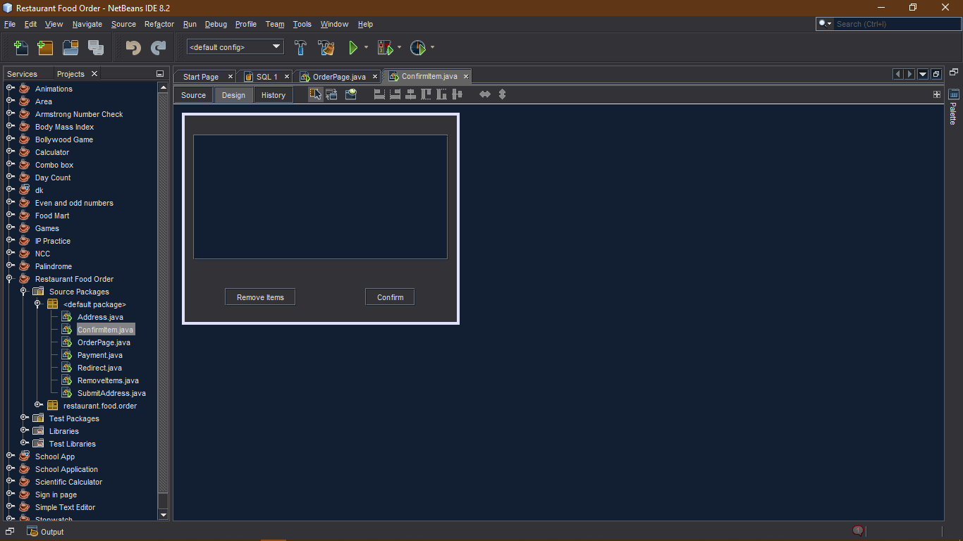

**public ConfirmItem() {**

**initComponents();**

jTextArea2.append("\n" + new OrderPage().c1);

jTextArea2.append("\n" + new OrderPage().c2);

jTextArea2.append("\n" + new OrderPage().c3);

jTextArea2.append("\n" + new OrderPage().c4);

jTextArea2.append("\n" + new OrderPage().c5);

**}**

**private void jButton1ActionPerformed(java.awt.event.ActionEvent evt) {**

this.setVisible(false);

new RemoveItems().setVisible(true);

**}**

**private void jButton2ActionPerformed(java.awt.event.ActionEvent evt) {**

this.setVisible(false);

new Address().setVisible(true);

**}**

**Frame 3 : Address**

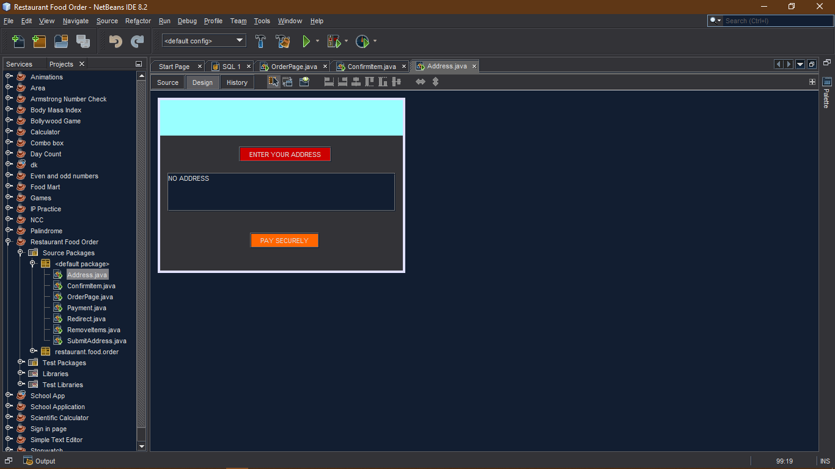

**public Address() {**

**initComponents();**

jTextArea1.setText(new SubmitAddress().address);

**}**

**private void jButton1ActionPerformed(java.awt.event.ActionEvent evt) {**

this.setVisible(false);

new SubmitAddress().setVisible(true);

**}**

**private void formWindowOpened(java.awt.event.WindowEvent evt) {**

if(jTextArea1.getText().isEmpty()==true)

{

jButton2.setEnabled(false);

}

else

{

jButton2.setEnabled(true);

}

**}**

**private void jButton2ActionPerformed(java.awt.event.ActionEvent evt) {**

this.setVisible(false);

new Payment().setVisible(true);

**}**

**Frame 4 : Submit Address**

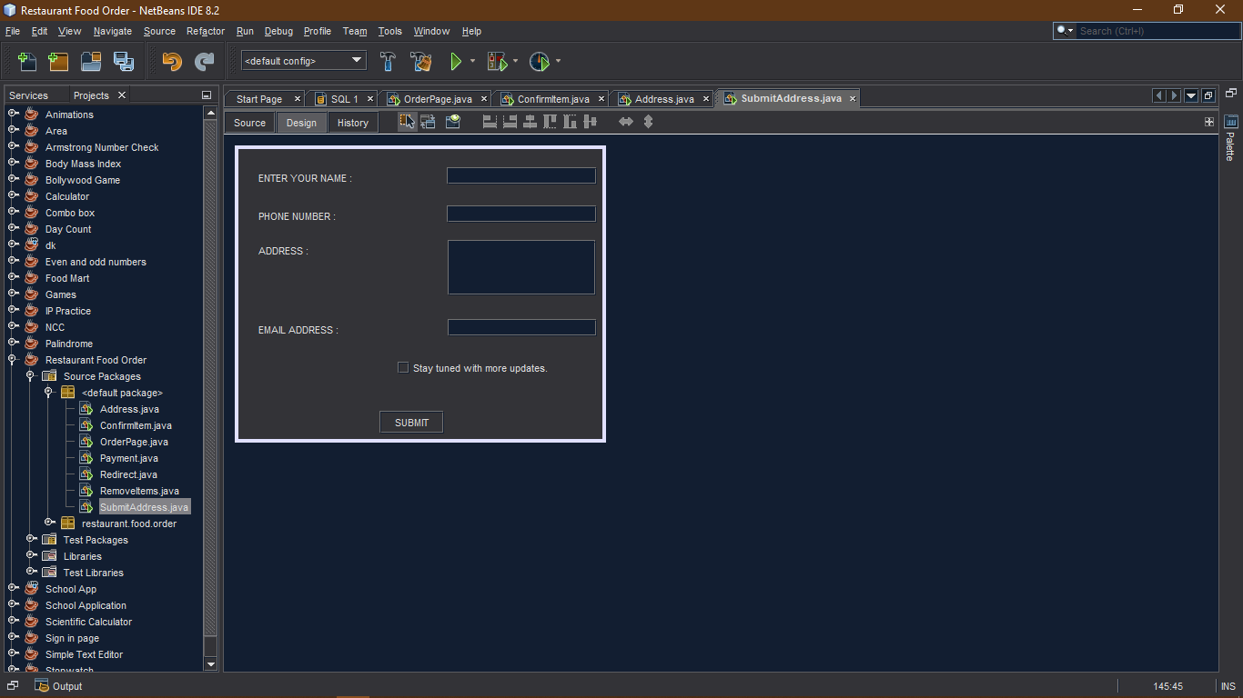

**public class SubmitAddress extends javax.swing.JFrame {**

static String address;

private void jButton1ActionPerformed(java.awt.event.ActionEvent evt) {

address= jTextArea1.getText();

if(jTextField1.getText().isEmpty() || jTextField2.getText().isEmpty() ||

jTextArea1.getText().isEmpty() || jTextField3.getText().isEmpty())

{

JOptionPane.showMessageDialog(this,"PLEASE FILL ALL THE COLUMNS");

}

else

{

this.setVisible(false);

new Address().setVisible(true);

}

**}**